

**UNIVERSITY INSTITUTE OF ENGINEERING**

**Department of Computer Science & Engineering**

**Subject Name:** Mobile Application Development

**Subject Code:** 20CSP356

**Submitted to: Submitted by:**

Er. Bhupinder Singh (E12856) Name: Yash Gupta

UID: 20BCS5009

Section: 20BCS-DM-716

Group: B

**INDEX**

|  |  |  |  |  |  |  |
| --- | --- | --- | --- | --- | --- | --- |
| **Ex. No** | **List of Experiments** | **Conduct (MM: 12)** | **Viva**  **(MM: 10)** | **Record (MM: 8)** | **Total**  **(MM: 30)** | **Remarks/Signature** |
| 1.1 |  |  |  |  |  |  |
| 1.2 |  |  |  |  |  |  |
| 1.3 |  |  |  |  |  |  |
| 2.1 |  |  |  |  |  |  |
| 2.2 |  |  |  |  |  |  |
| 2.3 |  |  |  |  |  |  |
| 2.4 |  |  |  |  |  |  |
| 3.1 |  |  |  |  |  |  |
| 3.2 |  |  |  |  |  |  |
| 3.3 |  |  |  |  |  |  |

**Experiment 1.1**

**Student Name: Yash Gupta UID: 20BCS5009**

**Branch: BE-CSE Section/Group:20BCS_DM-716 B**

**Semester: 6 Date of Performance:**

**Subject Name: MAD LAB Subject Code: 20CSP_356**

## Aim:

Installing and running Android Studio’s.

## Objective:

The objective is to know how to properly install all required files for running Android Studios in Java/Kotlin.

## Steps and output:

**Step 1: -** **System Requirements**

Software required for running Android Studio application –

Java JDK-19

JRE

**Step 2: - Setup Android Studio**

**Download Android Studio IDE and Install.**

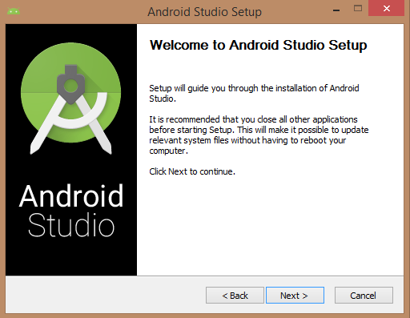

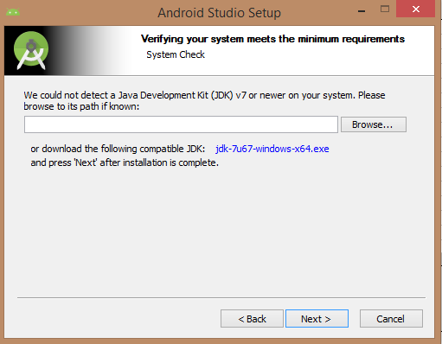

Below the image initiating JDK to android SDK

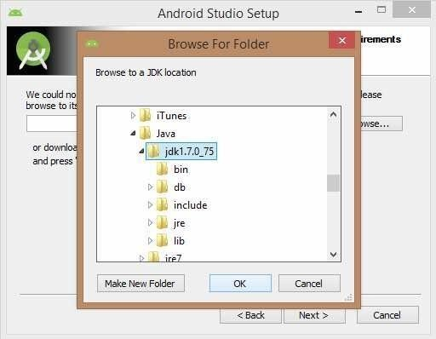

Choose the path / address location where you want to install Android IDE.

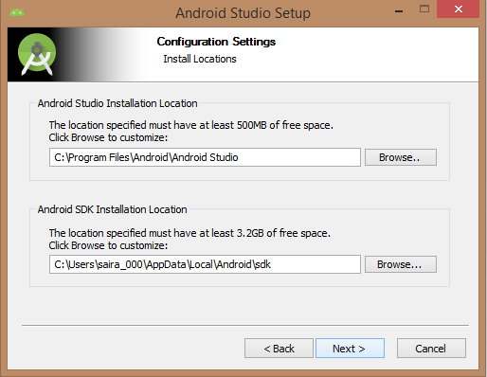

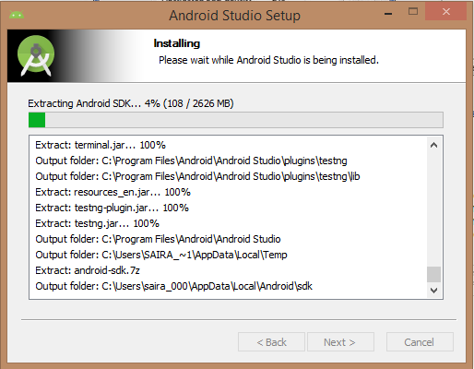

After Installation of Android Studio.

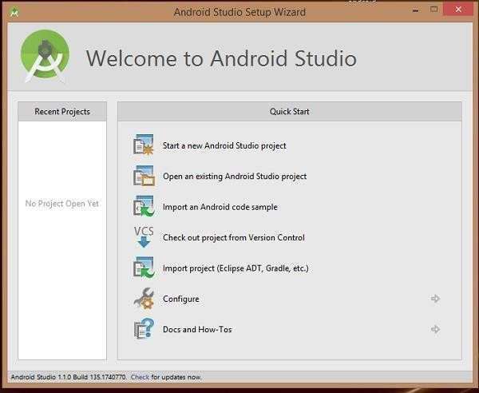

Creating New Project to get stated coding –

